Project Design Phase Problem – Solution Fit

Date | 6 February 2026
Team ID | LTVIP2026TMIDS36395
Project Name | Automated Car Catalog System for Enhanced Showroom Management  (ServiceNow Administration)
Marks | 2 Marks

The Problem
Car showrooms often rely on manual systems for catalog management, booking approvals, and communication with customers. This leads to several issues:
- Delayed approvals due to manual tracking
- Lack of transparency for customers during the booking process
- Inefficient management of vehicle categories and information
- Frequent customer follow-ups and complaints
- Poor coordination between salespersons and management
This creates a frustrating experience for both showroom staff and customers, ultimately impacting business operations and customer satisfaction.

The Solution
We developed an automated, categorized car catalog system using
ServiceNow. The solution includes:
- A structured digital catalog (Mahendra) with categories like Sudden, XUV, and Sports
- Detailed catalog items: Polo, Thar, XUV700 – with descriptions, images, and pricing

- A two-level approval workflow to streamline request verification (Salesperson → Supervisor)
- Email notifications to inform users about approval or rejection
- A custom task fulfillment table for tracking request progress
- Integration with the Service Portal to allow customers to request cars easily and track their request status

Why This Solution Works
- It directly targets showroom inefficiencies by digitizing manual tasks
- It aligns with customer behavior – users prefer online browsing, instant updates, and clear communication
- Showroom staff gain visibility and structure in managing car requests and tasks
- Approval workflows eliminate bottlenecks, speeding up decision-making
- Email notifications reduce manual communication and keep everyone informed

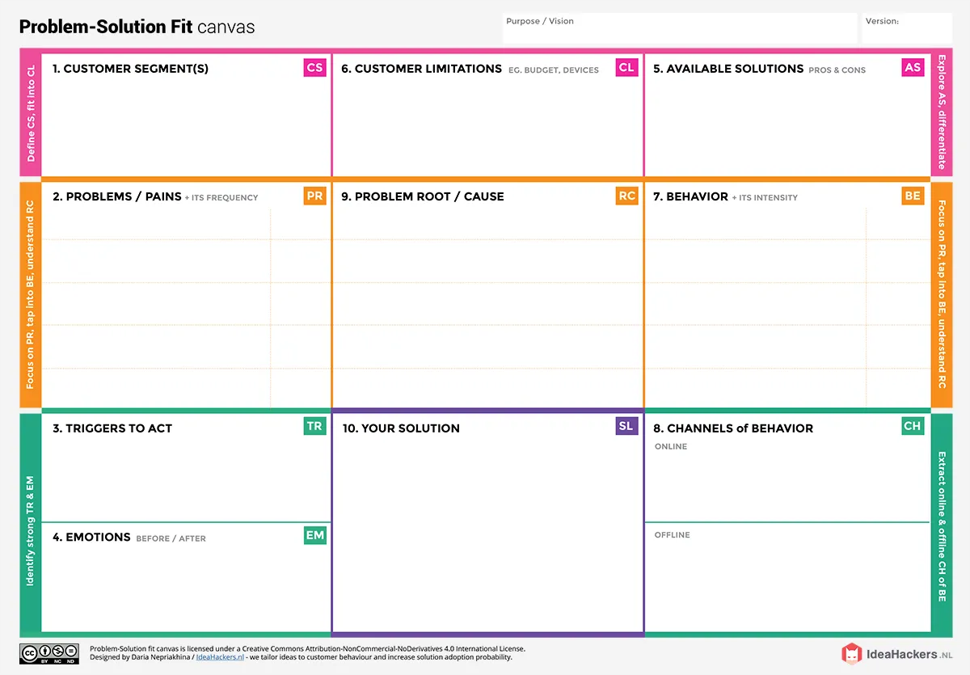
Staff handle approvals or status updates through in-person communication or phone calls.
Customers use the ServiceNow Service Portal to request and track car bookings.
A fully automated catalog system called Mahendra on ServiceNow
Categorized cars (Sudden, XUV, Sports)
Multi-level approvals, email notifications
Custom task table for request tracking
Repeated delays in approvals,
Inconsistent or lost booking
requests, Increasing demand for digital options by customers

Individual car buyers browsing or visiting the showroom, Salespersons handling customer requests, delivery coordination
No access to real-time information, Dependence on staff for every step,
No centralized platform for tracking
Manual booking via paper or phone, Excel logs maintained by staff, Basic inquiry forms without status tracking, CRM tools not tailored for car showroom flow

No digital catalog; only paper or verbal communication
Delayed approvals due to manual workflows
Customers unaware of request status
Staff struggle with repetitive follow-ups
Lack of a digital, centralized booking and catalog system
Manual approvals and tracking
No automation or structured workflows
Customers browse models and submit requests via the portal
Staff approve/reject requests in the workflow
Tasks are assigned and tracked in the backend
Users receive email updates at every stage

Before: Frustrated, uncertain, impatient
After: Informed, confident, satisfied

